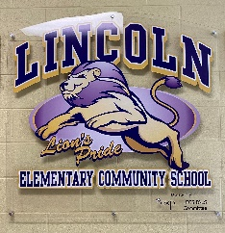
Principal: Fern Touchie Instagram: @lincolnlions2021
Administrative Assistant: Susanna Withers Twitter: @lincolnlion2021 Phone: 357-4075 Website: http://lincoln.nbed.nb.ca

Lions’ Pride. Lead and Learn with the Lincoln Lions

November 2021
Dates to Remember:
Wed. Nov 3 | PALS Meeting 6:30 – 7:30 pm
Tues. Nov 9  Rain date  Wed. Nov 10 | Remembrance Day  Ceremony
Thurs. Nov 11 | NO SCHOOL for students (Remembrance Day holiday)
Week of  Nov 15 - 19 | Diversity and Respect Week
Wed. Nov 17 | PSSC Meeting 6:30 – 7:30pm
Fri. Nov 19 | NO SCHOOL for students (Professional Development for teachers)
Fri. Nov 26th | LECS Clothing Orders Due
Mon. Nov 29 | Report cards go home
Thurs. Dec 2 | Parent Teacher Interviews (Virtually) 4pm – 7pm
Fri. Dec 3 | NO SCHOOL for students, (Parent/teacher interviews in the morning and PL in the afternoon)
Popcorn Sale – Order form was sent home with students to order for the month. Popcorn cost is $1.00 per bag. All proceeds will go to wellness initiatives for our LECS students.
Student Survey – Our Grade 4-5 students will be participating in the Annual Provincial Student Survey (formerly known as the OurSchool Survey) once they return. We will also have our LECS student wellness survey that our K-5 students will be participating in. This information will be used to guide our School Improvement Plan.
Remembrance Day Ceremony – We will be having an outdoor school ceremony on November 9th with a rain date of the 10th. Unfortunately, due to COVID restrictions we are unable to have a large ceremony with visitors/guests. Photos will be posted on our social media accounts.
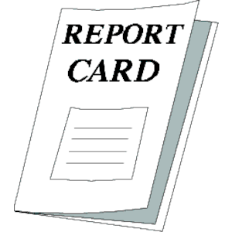
Report Cards and Parent/Teacher Interviews
Report cards will be given to students on Nov 29th. Due to Covid19 Public Health restrictions, parent-teacher interviews will occur via telephone or virtually on Teams Thursday December 2nd from 4:00 – 7:00 pm and Friday, December 3rd from 8:30-11:30 am. Your child’s teacher will contact you to arrange a time.

School Cancellations - We are ZONE 7 for school closures. Also, please remember that we
always need to be able to reach you during the school day, in case of emergency or closure during the school day. Make sure that your contact information is updated, please contact the office, 357-4075.

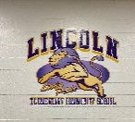
School Clothing Orders - School Clothing options will be put on our website for parents to view very soon. We are offering youth size hoody, t-shirt, and toque this year, along with adult products. All products are quality items purchased through Valley Graphics. If you are interested, ordering will be through Cashless Schools and you will get notification when the clothing is available to be purchased. If we are unable to set up Cashless Schools in time, we will send out the order forms with students. Great idea for Christmas gifts!! Deadline is November 26th so that orders will be available before Christmas. Let’s show our Lions’ Pride!!

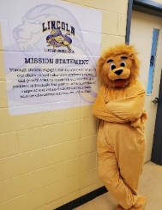
Lincoln Lion’s Monthy Roar!
Thank you to our Lincoln Families for sending in treats for our “Trunk & Treat” Halloween celebration. Though we did not get a chance to have our event on Friday the support was amazing. We will be deciding on how to share these items with our students when they return. Thank you to our PALS committee for organizing this event for our students.
Also thank you to our PALS committee for purchasing pizza for our LECS students on Thursday October 28th in celebration of our Terry Fox Fundraiser this year. The students were very appreciative! Thank you to Pizza Twice as well for accommodating our order on a very busy day.
And a BIG thank you to Ruth Claybourn for decorating our school for Halloween week and for all the work she does with her volunteers for our Hot Lunch and Breakfast Programs. We could not have these programs without their hard work and support!

November’s CARE theme:
Compassion for Others
Our students are learning about the importance of thinking about others. Throughout the month of November, we will focus on learning about ways in which we can show compassion. We encourage students to show compassion to their peers so that Lincoln Elementary continues to be a happy place to grow and learn.

